**Computing Studies & Information Systems**

"Applied Research Project"

Fall 2022: CSIS 4495 – Section 050

**Midterm Report**

**“TeamSavvy”**



**by:**

* **Name:** Jasmine Kaur **Student ID:** 300345933
* **Name:** Jaspal Singh **Student ID:** 300345938
* **Name:** Harman Lal **Student ID:** 300343291
* **Name:** Joling Weng **Student ID:** 300335548

Table of Contents

Statement of the Problem: 3

Significance of the study 3

Who would benefit from this project and how? 3

Users 4

Proof of Progress 5

Android App for employee’s biometric 5

APIs 8

UI Design using Adobe XD 11

Front-end 14

Database 22

Features/module with objectives 25

Set up the environment 25

Software Design Architecture 25

# Statement of the Problem:

TeamSavvyhelps create an environment that motivates communication and keeps employees and managers working together to meet company goals.It also helps the company to manage the information and activities of employees.

The issue with the existing system is to access data about employee projects, leaves, payroll, and jobs applied internally, for accessing these details an individual has to use different web platforms.

Our system proposes that a person can access the details for projects, work history, team hierarchy, peers, timesheets, leaves and payroll information on one platform. The managers and company owners can access the records of employees and also check the profile of the candidates who applied for jobs on their company website with an improved user interface for a better user experience.

# Significance of the study

## Who would benefit from this project and how?

**Employee Engagement:** Our platform will provide employees to add their details, apply for leaves, and check their work history and payroll details on one platform. This will save time for an individual to concentrate on tasks for company growth. Employees can track their growth and improve their working efficiency.

**Biometric:** We will create an android app to get user biometric timestamp and will store it in the database. Employee can use his biometric to clock-in and clock-out of the system.

**Create Dashboard:** Our project will provide the dashboard of collective data of employees. A manager or company owner can perform descriptive analysis on employee’s data; with respect to programming languages, projects, leaves (sick leave, casual leave) in specific period and, salary. **We will give different graph options to select from and, can create multiple graphs to visualize data and show the dashboard on preview mode and can download it.** The HR at a company can do analytics; for example, number of employees have knowledge of programming language, salary of each employee in specific project. We will represent this information in a graphical format.

**Create Task:** The employee can fill his hours he is working on a particular task and then change the status of task to in-progress, after completing the task employee can change the task status to finish. The notification will be sent to the manager that this task has been completed. Manager can track the progress of the tasks assigned to team members.

**Improve communication:** Our platform provides the information of each employee to others by search option that will let them to stay connected, and an easy path for new joiners to get to know their peers. All in all, improve the connection which will reduce the problem of communication gap within an organization.

## Users

Employee**:**

* An employee will have access to a calendar where he can see clock-in and clock-out for a day
* Check total working hours
* Apply for leaves
* Check his payroll details (Read only),
* Get information of other employee working in an organization for communication
* Can get the team hierarchy
* Check the number and details of projects he is working on
* Employee will have the profile page where he will have his information saved or can update if required
* Can apply on internal jobs
* Apply for resignation

Admin (HR or Manager):

* An admin will have all the functionality that employee has
* Able to see information of employees in his team
* He can perform CRUD operations on them
* Check payroll info and can give increment to an employee
* Admin will have details of project’s budget and deadline
* Can assign project to employee
* Modify involvement of employees in different projects,
* Can approve leaves of an employee
* Check timesheets
* Create internal job postings for employees.
* Super admin (Company Owner): A super admin can perform CRUD operations on admins and employees.

# Proof of Progress

## Android App for employee’s biometric

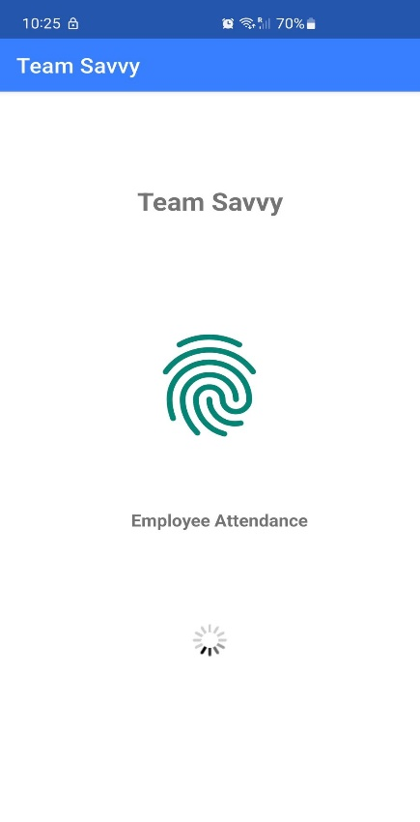

Landing screen for an employee showcasing the project name, image, message for an employee for the attendance and loader.

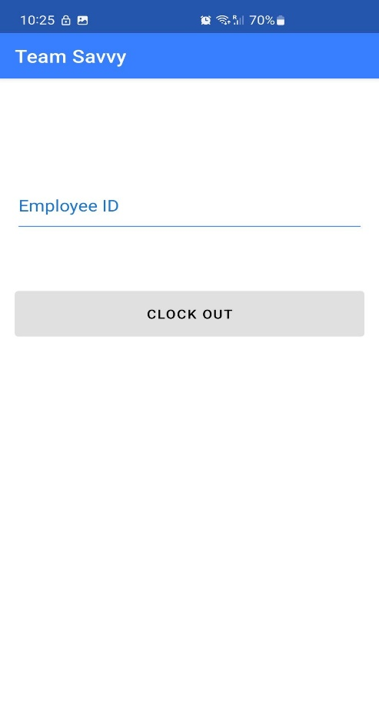

This screen will ask employee for their employee

ID and allow him to clock-in or clock-out.

We are still working on design and few features.

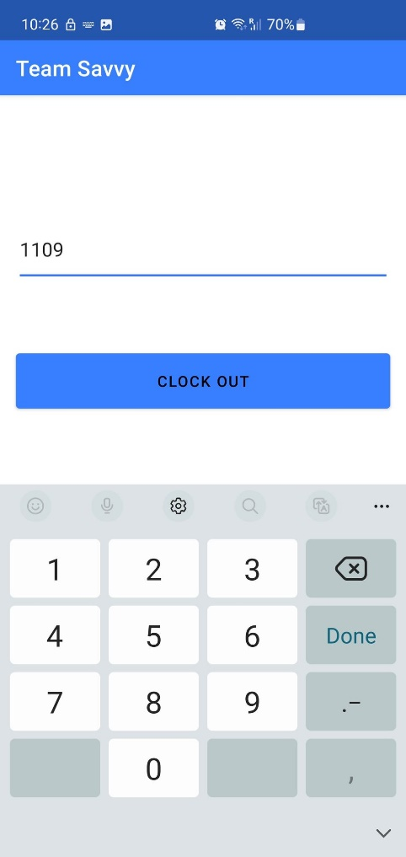

After entering the employee id the button will be activated.

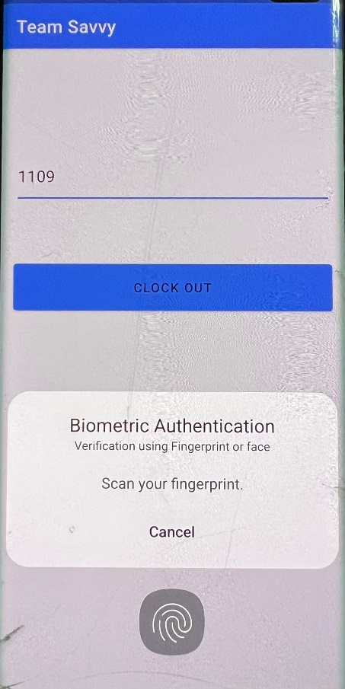

The app will ask for biometric verification, if the fingerprint matches to the record of fingerprint

in device the app will accept and allow user to clock-in or clock-out.

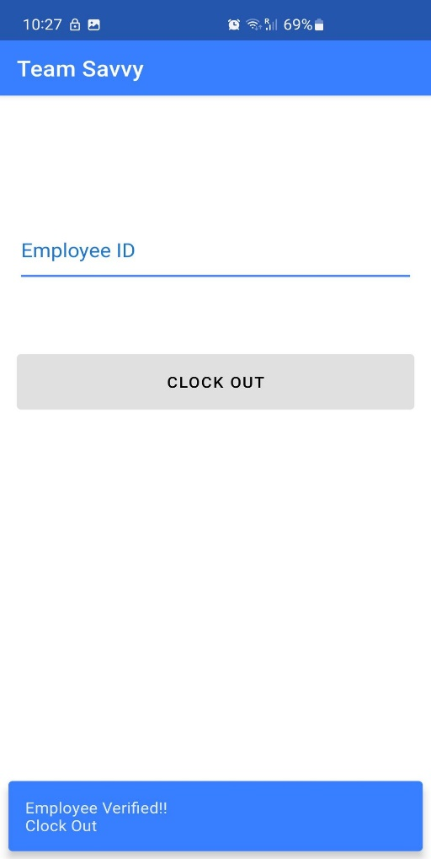

At last, the app will show the snack bar to show if an employee has been verified or not also displays the status clock-in or clock-out.

## APIs

We have created API in .NET CORE using Entity Framework, LINQ, Automapper and swagger documentation.

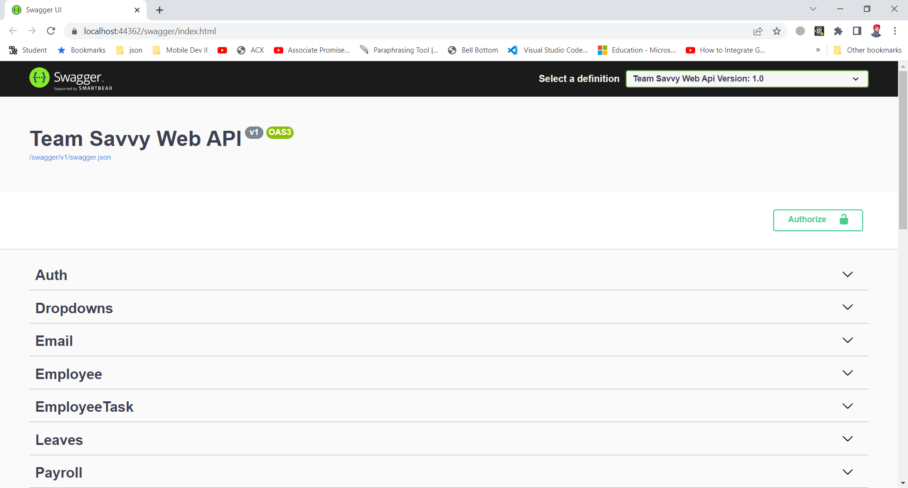

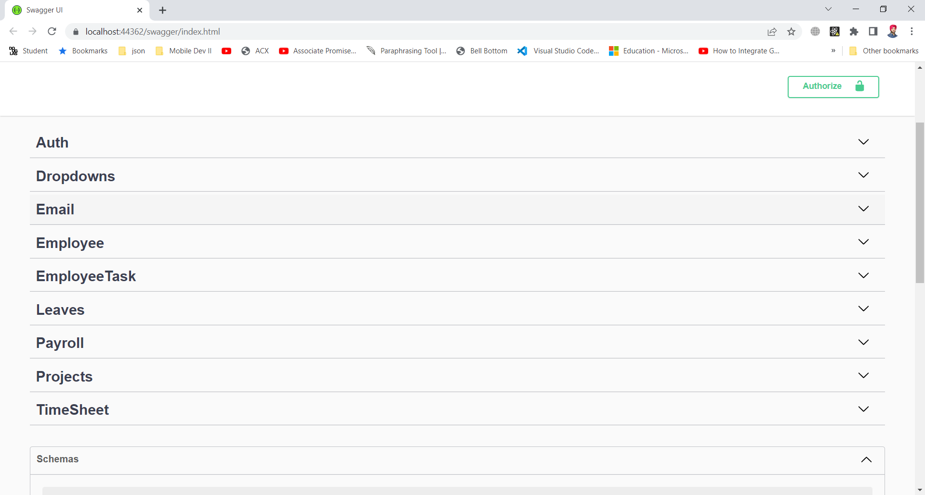

This is the swagger documentation to give a user interface to an API so developer can test API like postman. In this interface we can test all the request like post, delete, update, and get request. Above are the endpoints for Auth (Authorization), Dropdown, Email, Employee, Employee Task, Leaves, Payroll, Projects and Timesheet controllers.

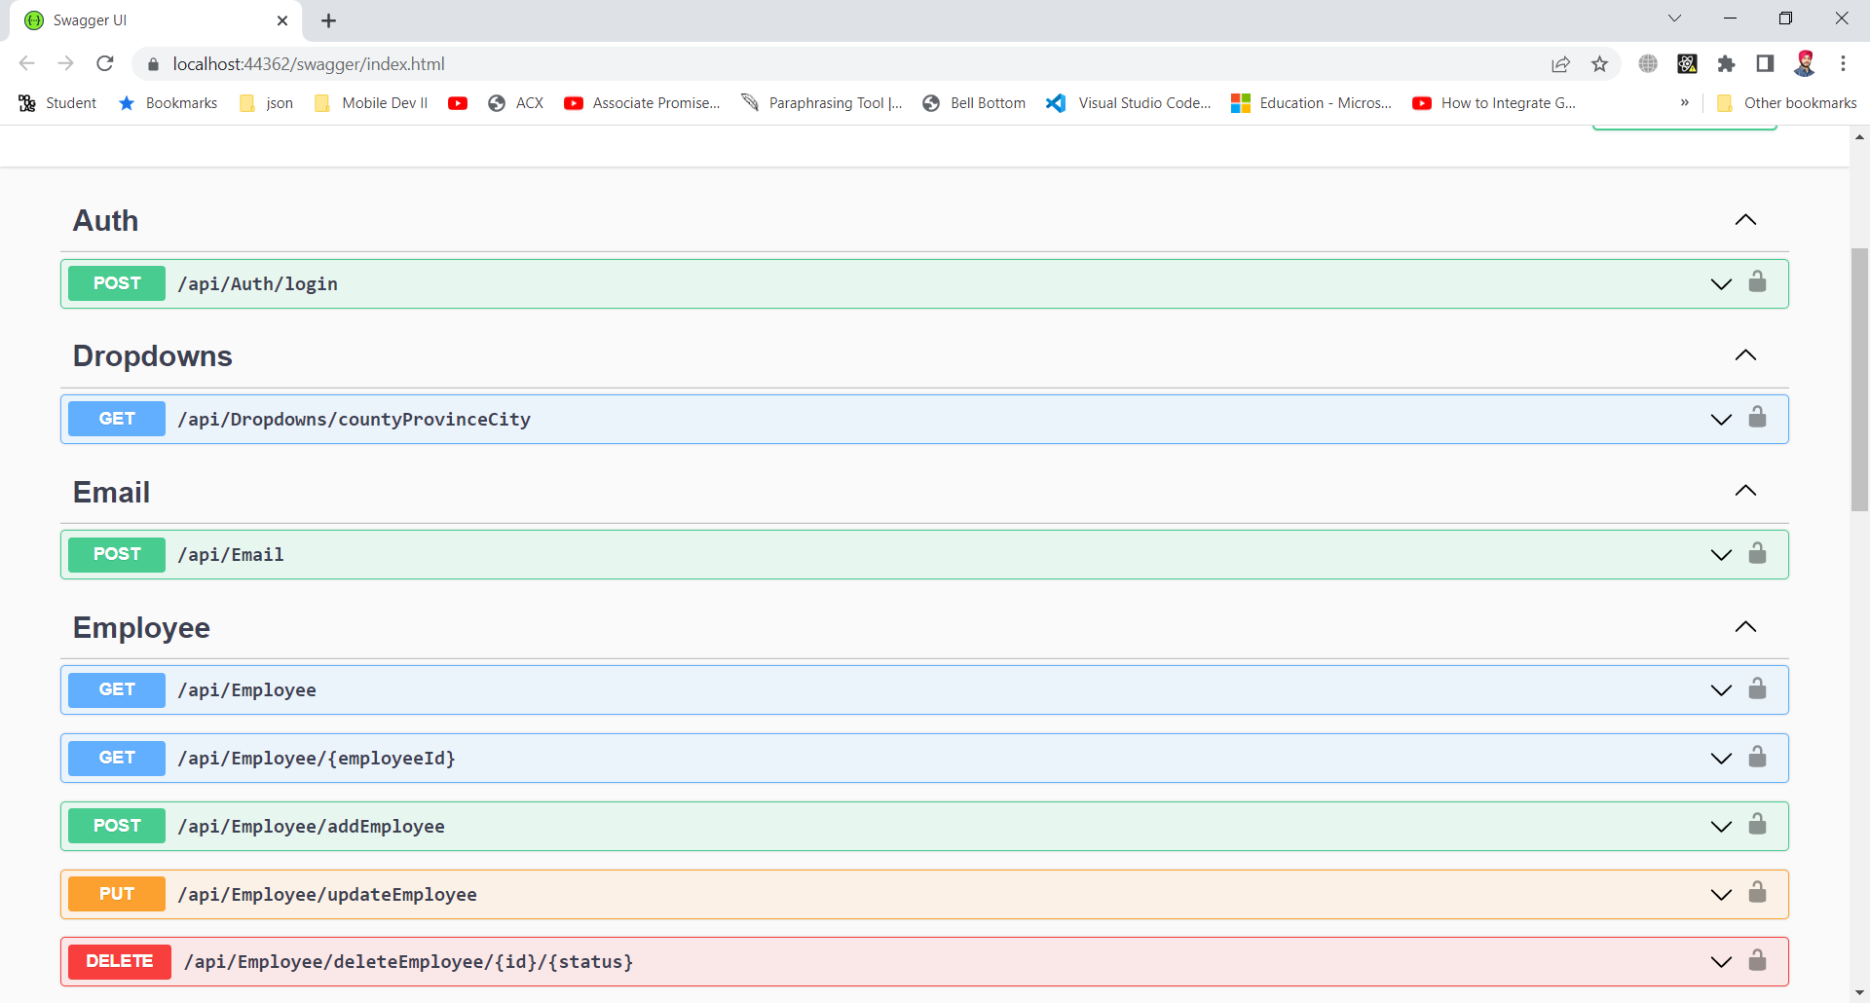

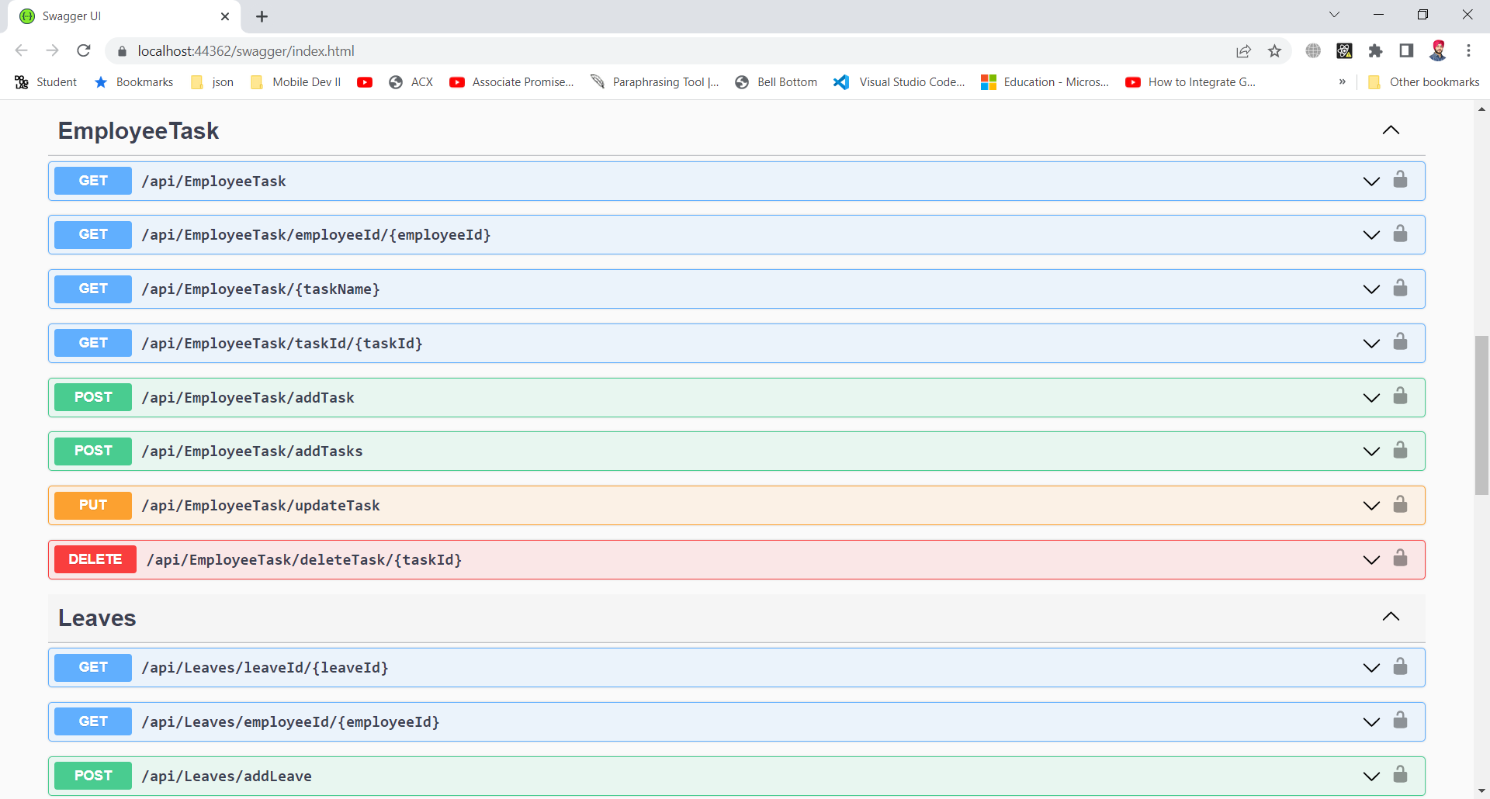

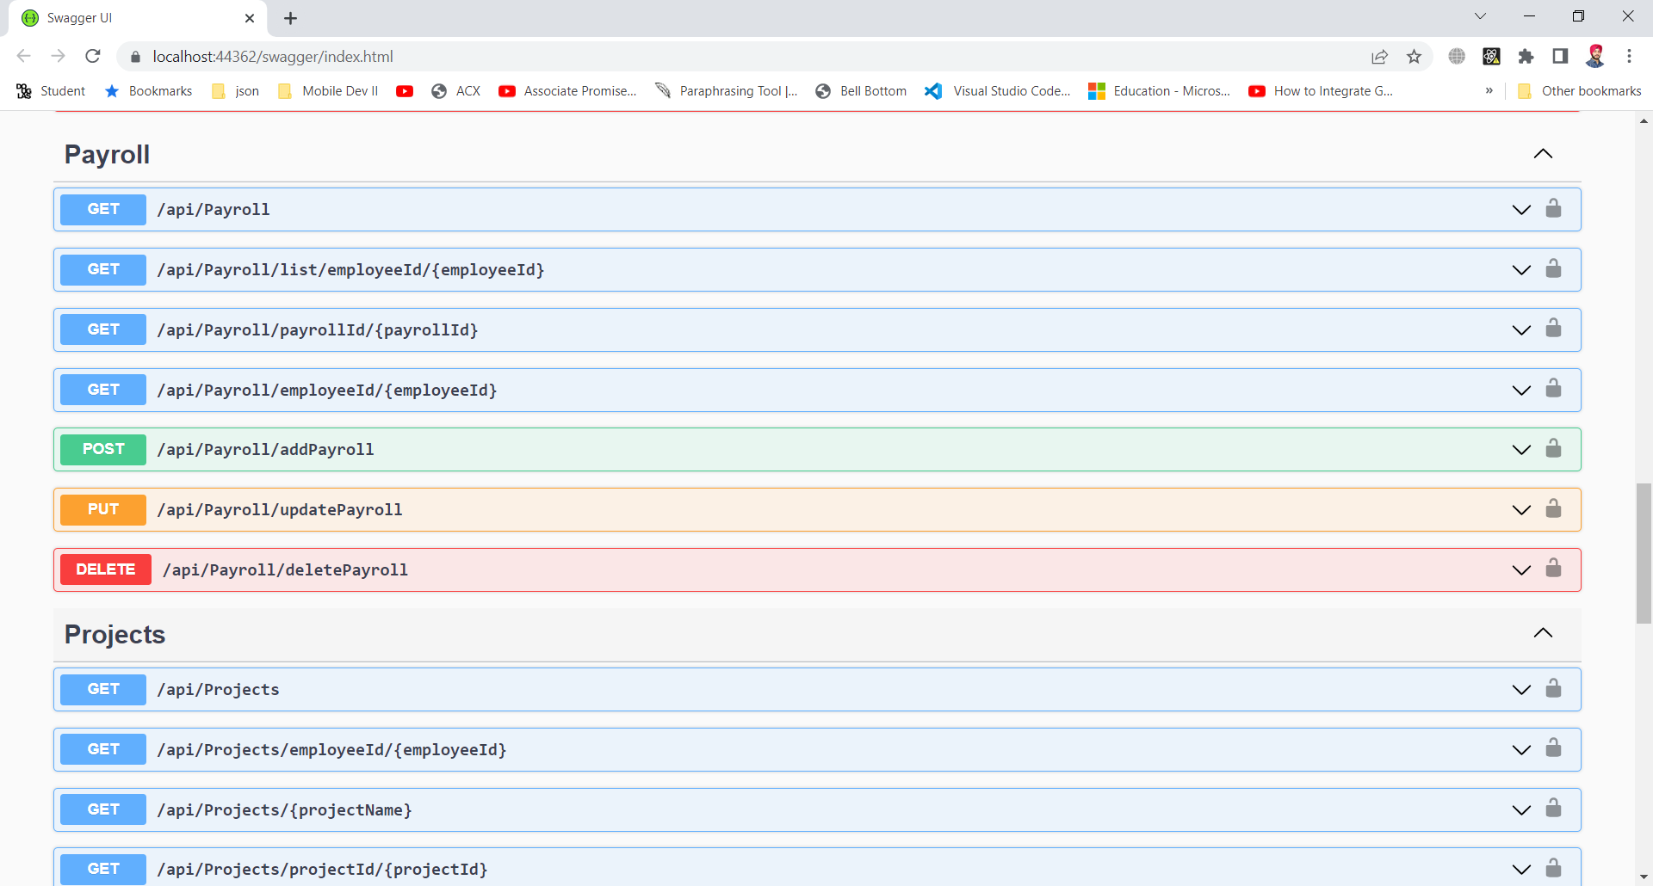

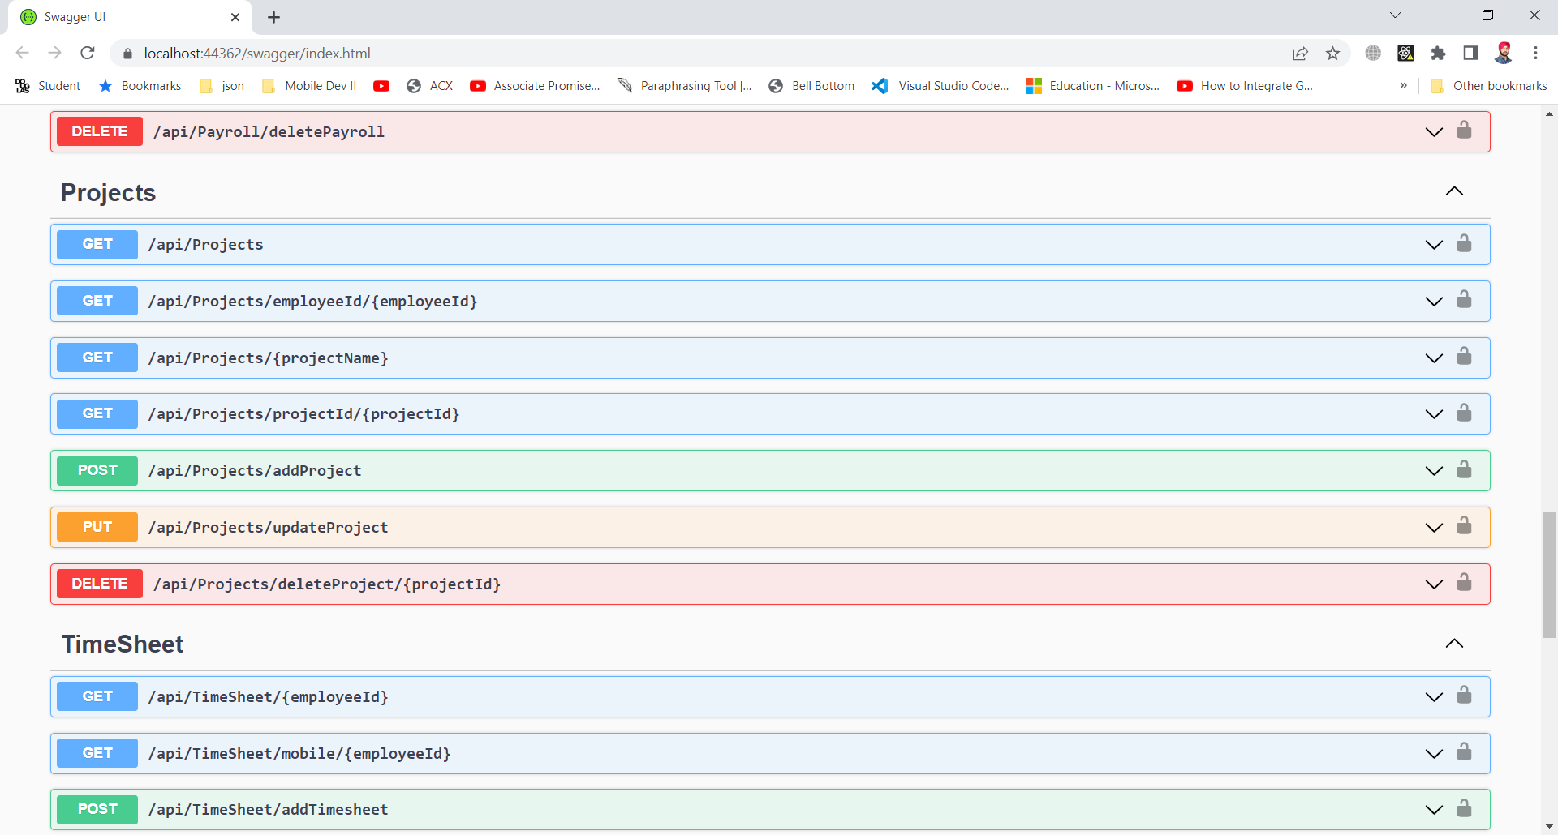

Above screenshots showing separate endpoints (GET,POST,PUT,DELETE) of all controllers created.

## UI Design using Adobe XD

The snapshots below shows the flow of our application. Design Link:

<https://xd.adobe.com/view/732c0d35-1e41-41d7-876c-25bde1a844a9-267f/?fullscreen>

**Login:**

The employee and admin will login with the predefined credentials provided by organization.

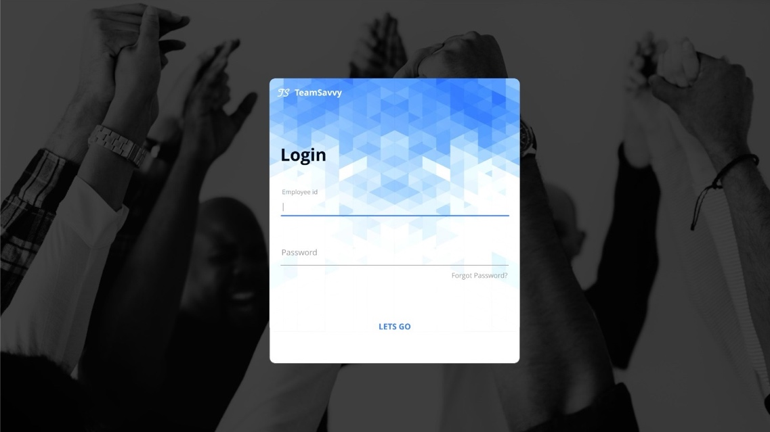

**Timesheet:**

This screen will show the information of employee clock-in and clock-out, with total hours they worked per week. Additionally, employee can apply for leaves and it will be displayed on the calendar

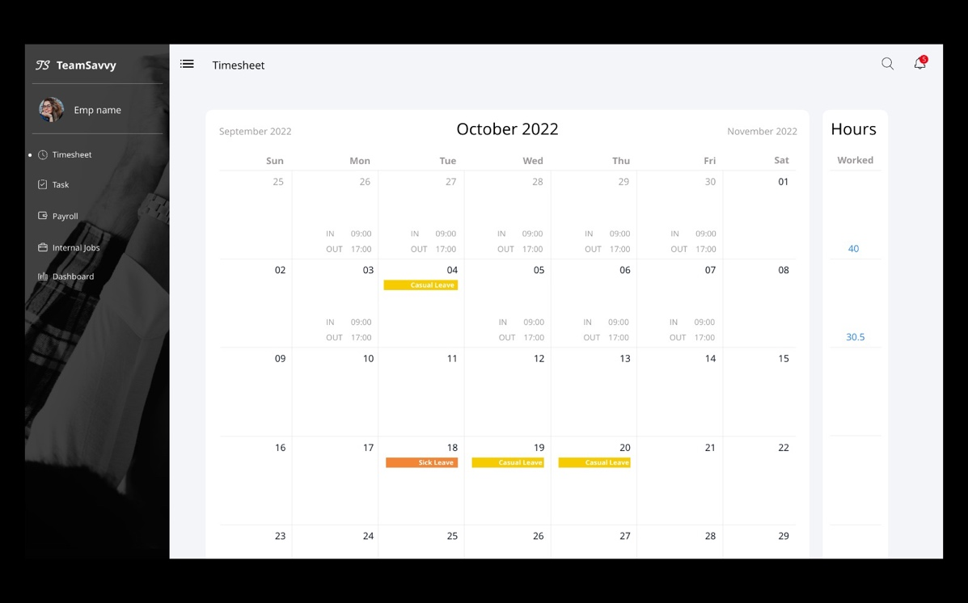

**Task:**

Task screen will have the assigned task for an employee, which he can modify to add hours, start date, and end date. Employee can also change the status from assigned to in-progress and then by using update status in in-progress lane he can change status to completed.

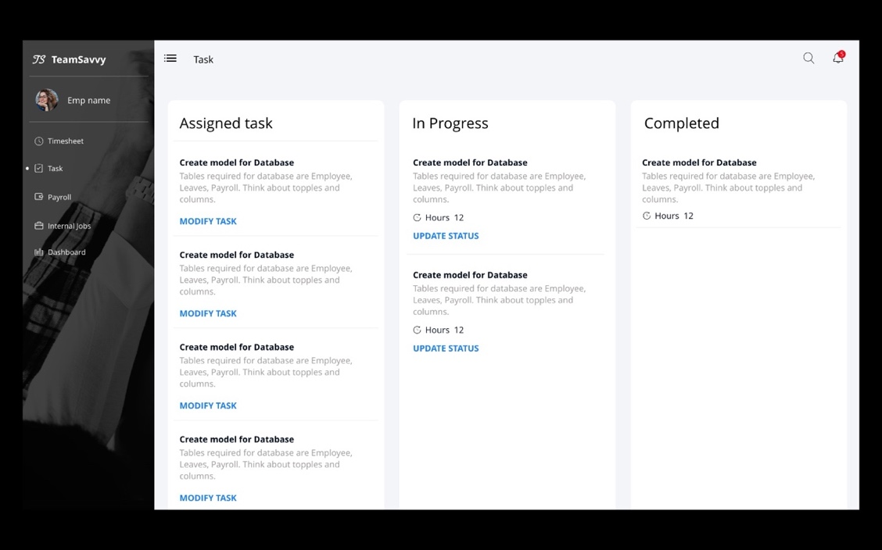

**Payroll:**

This screen will have the collection of pay slips with information of each month, total hours, and earnings, from here user can view each pay slip. The Pay Slip contains all the Earnings of an employee at the company from the date he has joined.

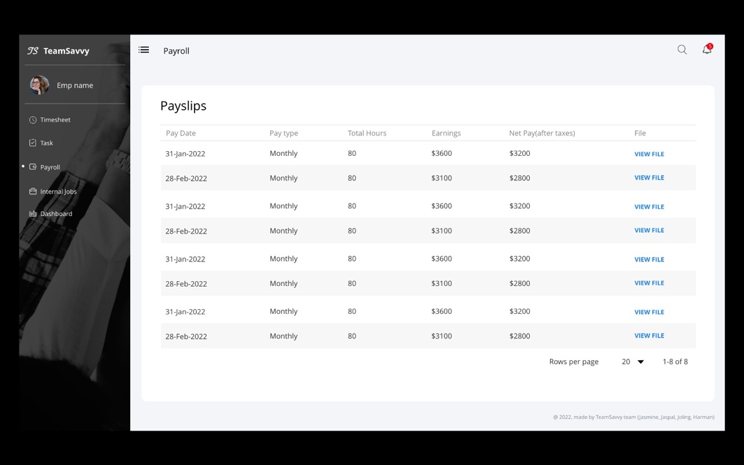

**Internal Jobs:**

This screen will display employee with the internal jobs postings which he can read the description and apply for the jobs.

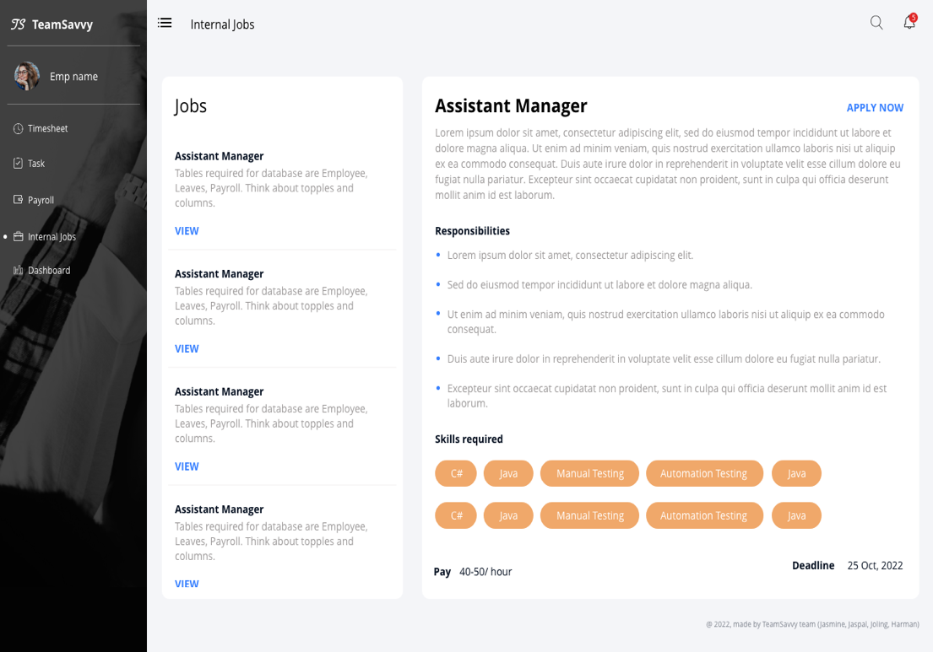

**User Profile:**

This screen will show the personal details, team members, position, department, skill set and bank details of an employee.

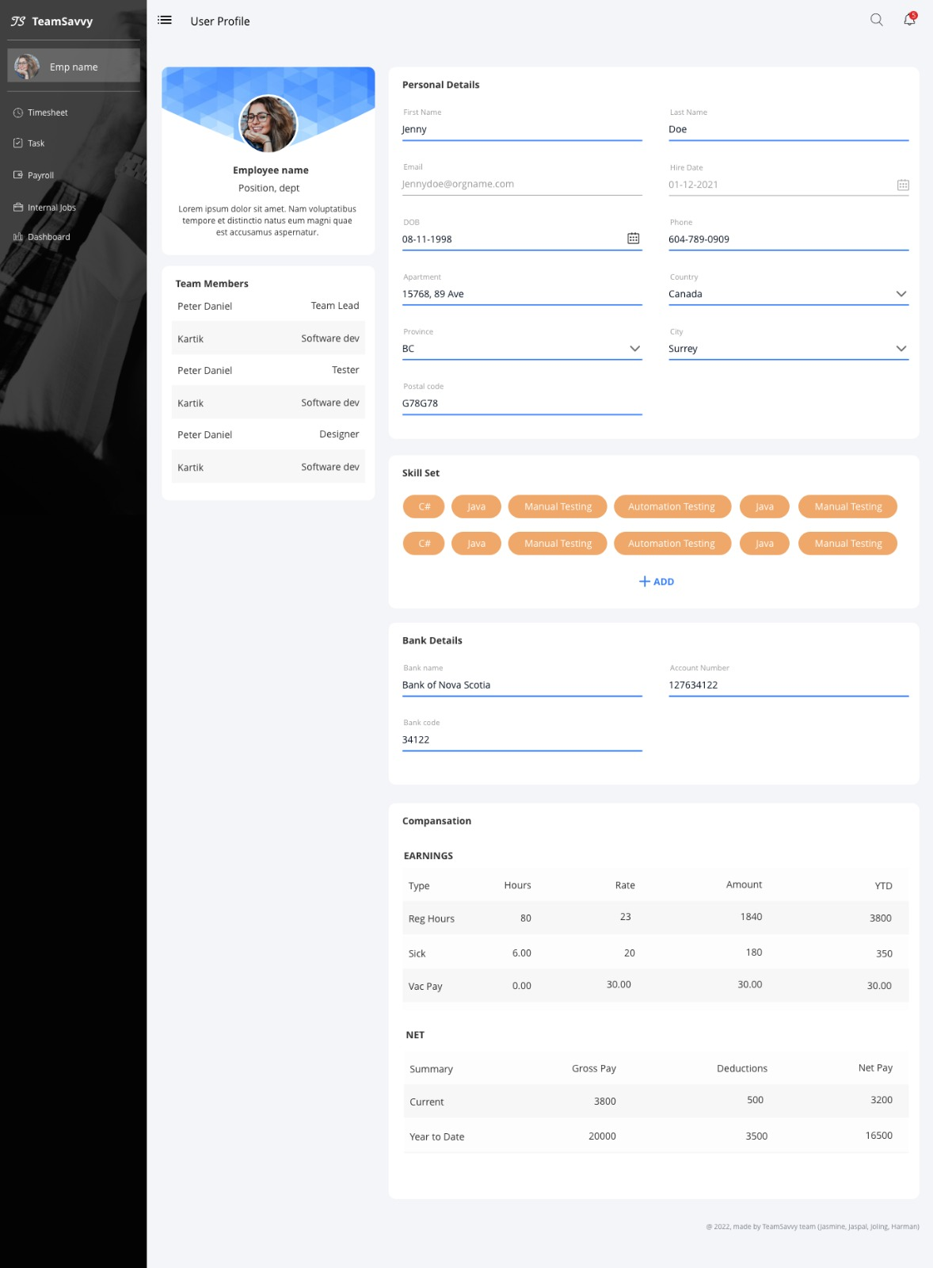

**Dashboard:**

This screen is for manager and HR, here they can view projects, team members, tasks, and other information. This screen will also have feature to create graphs widgets with predefined dropdowns. Manager can download, modify and delete the graph.

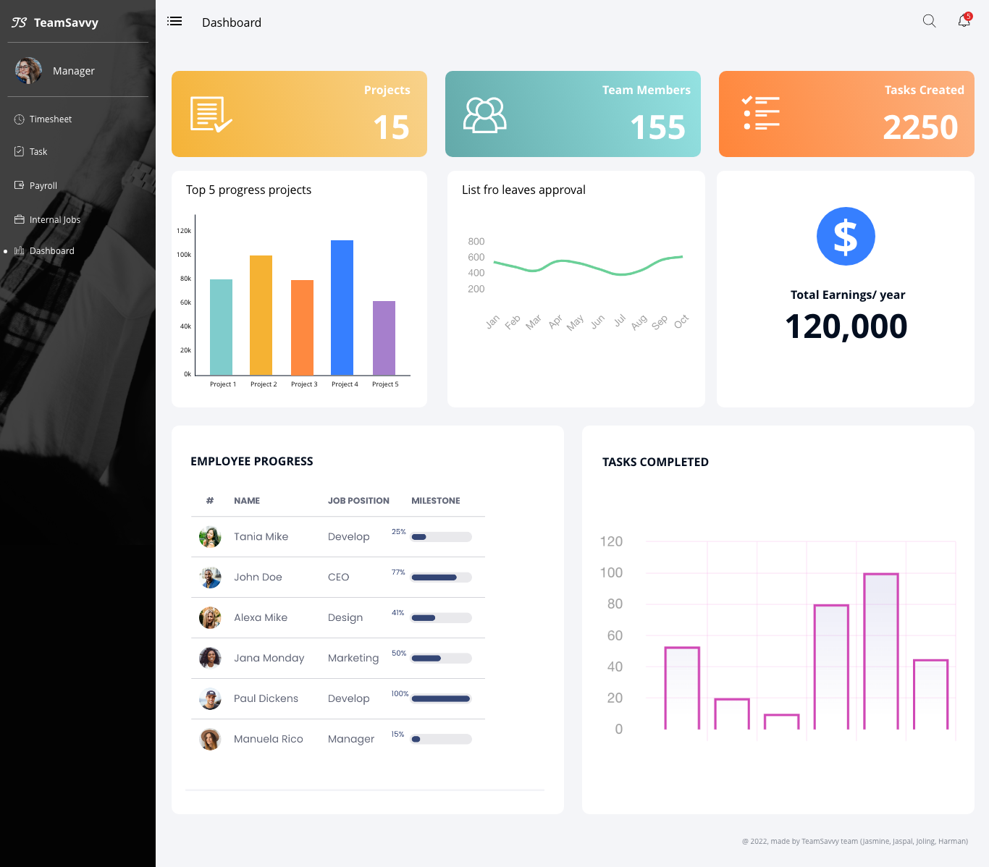

## Front-end

We started working with react js, bootstrap for developing our front-end with responsive screens, we decided to start with role ’employee’. Pages we have achieved so far:

**Login:**

This screen will allow users to login with credentials provided by organization or can reset password using OTP

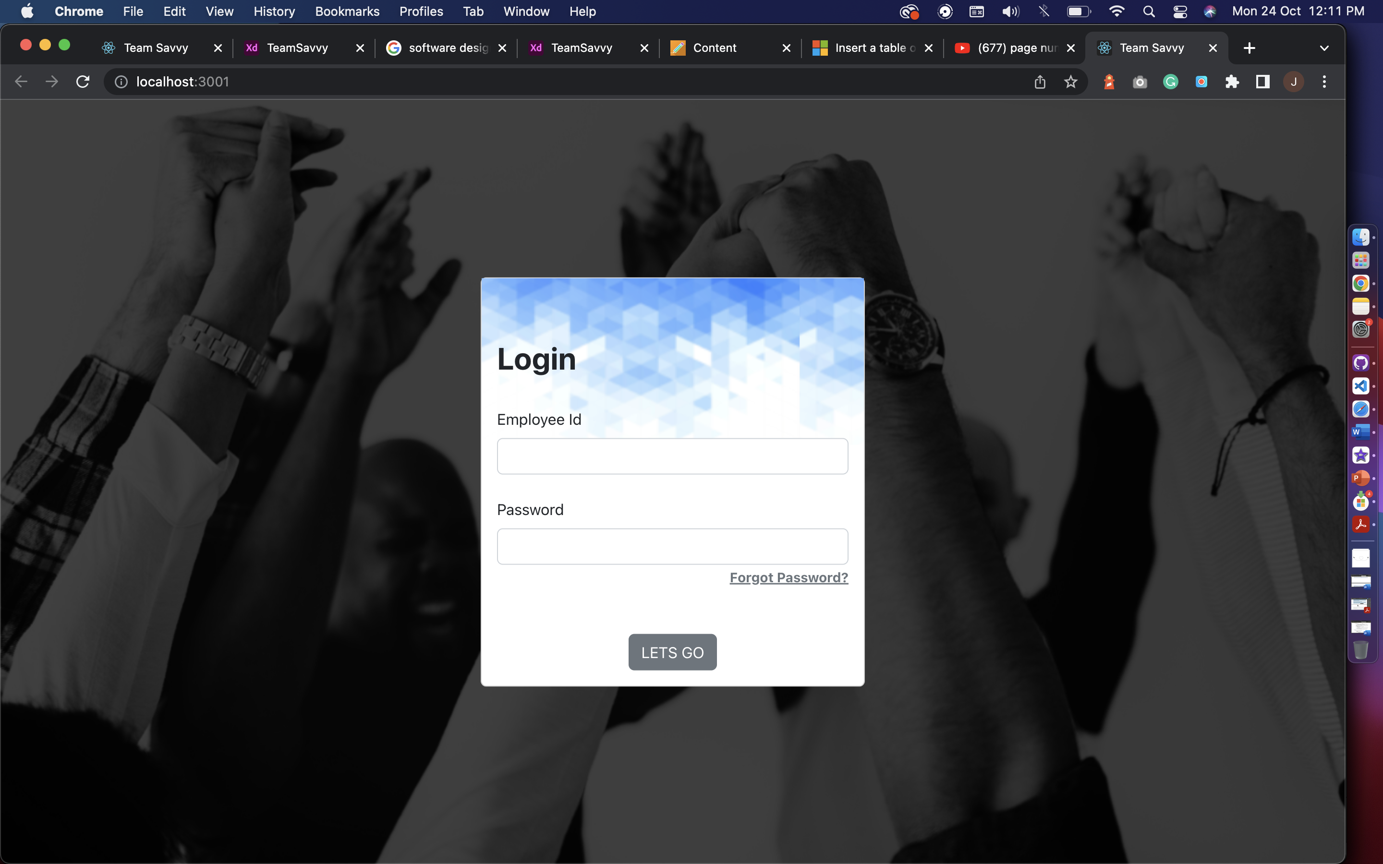

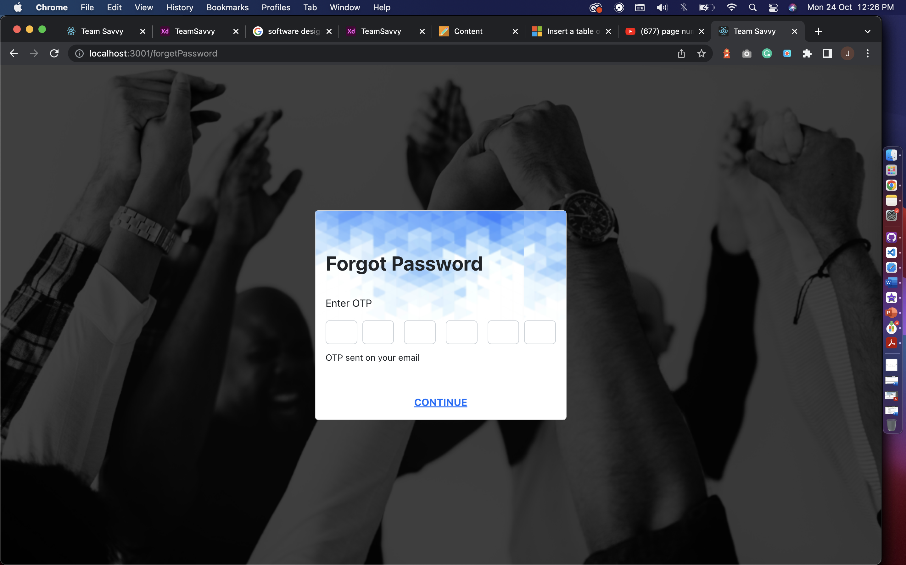

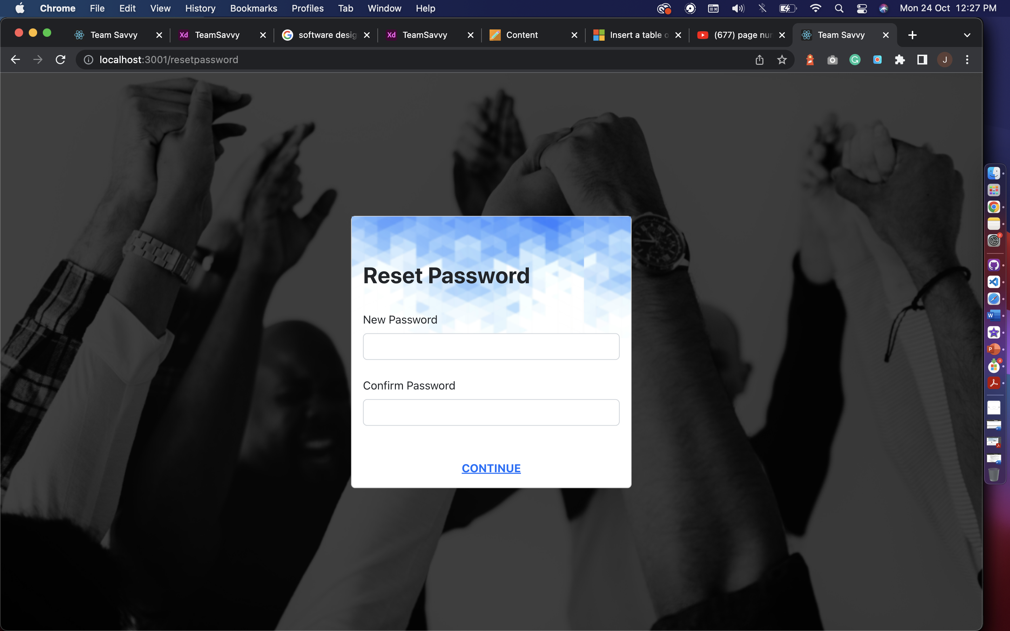

**Sidenav:**

The animated sidebar with navigation links to access the platform.

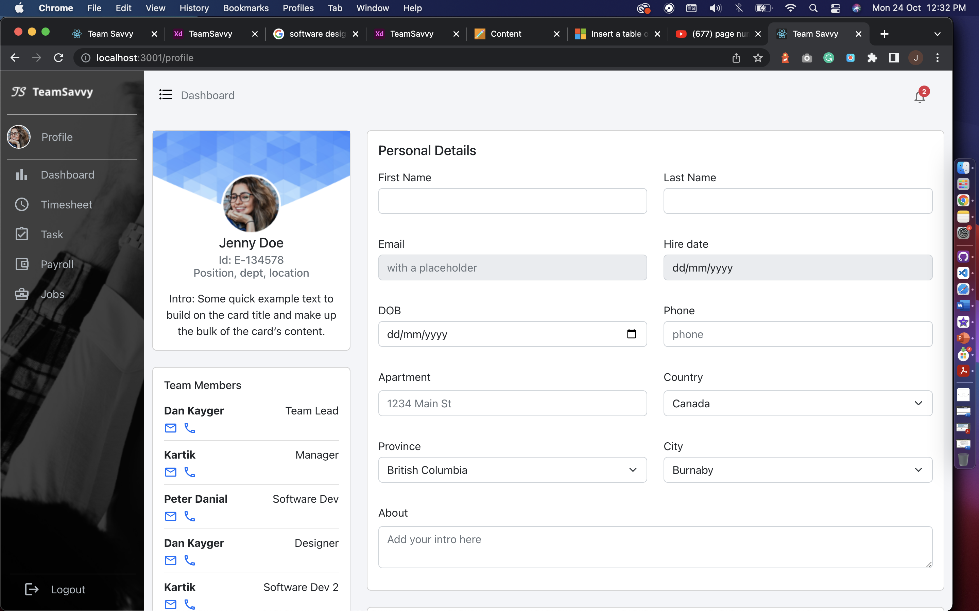 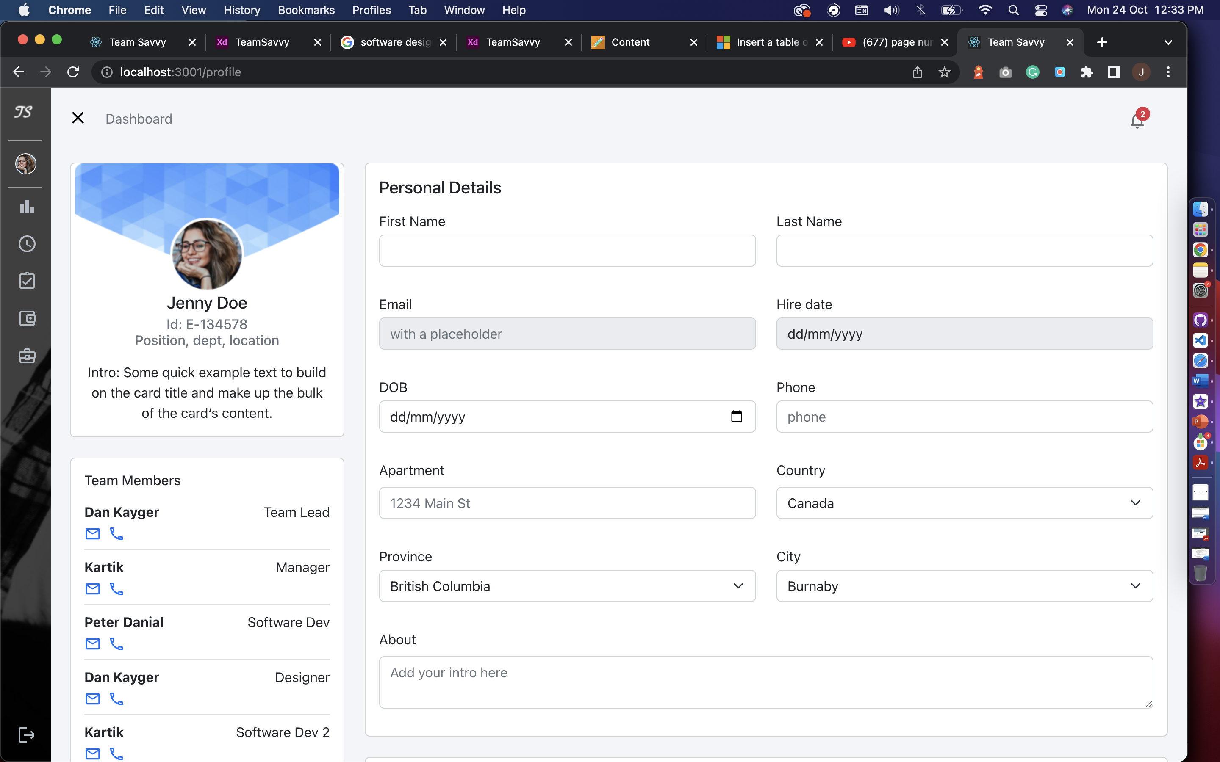

**Open** **Closed**

**Header and Navigation:**

Header has dashboard title which will be breadcrumb for navigation and notification with indicator, it is hardcoded for now. We will work on it after midterm.

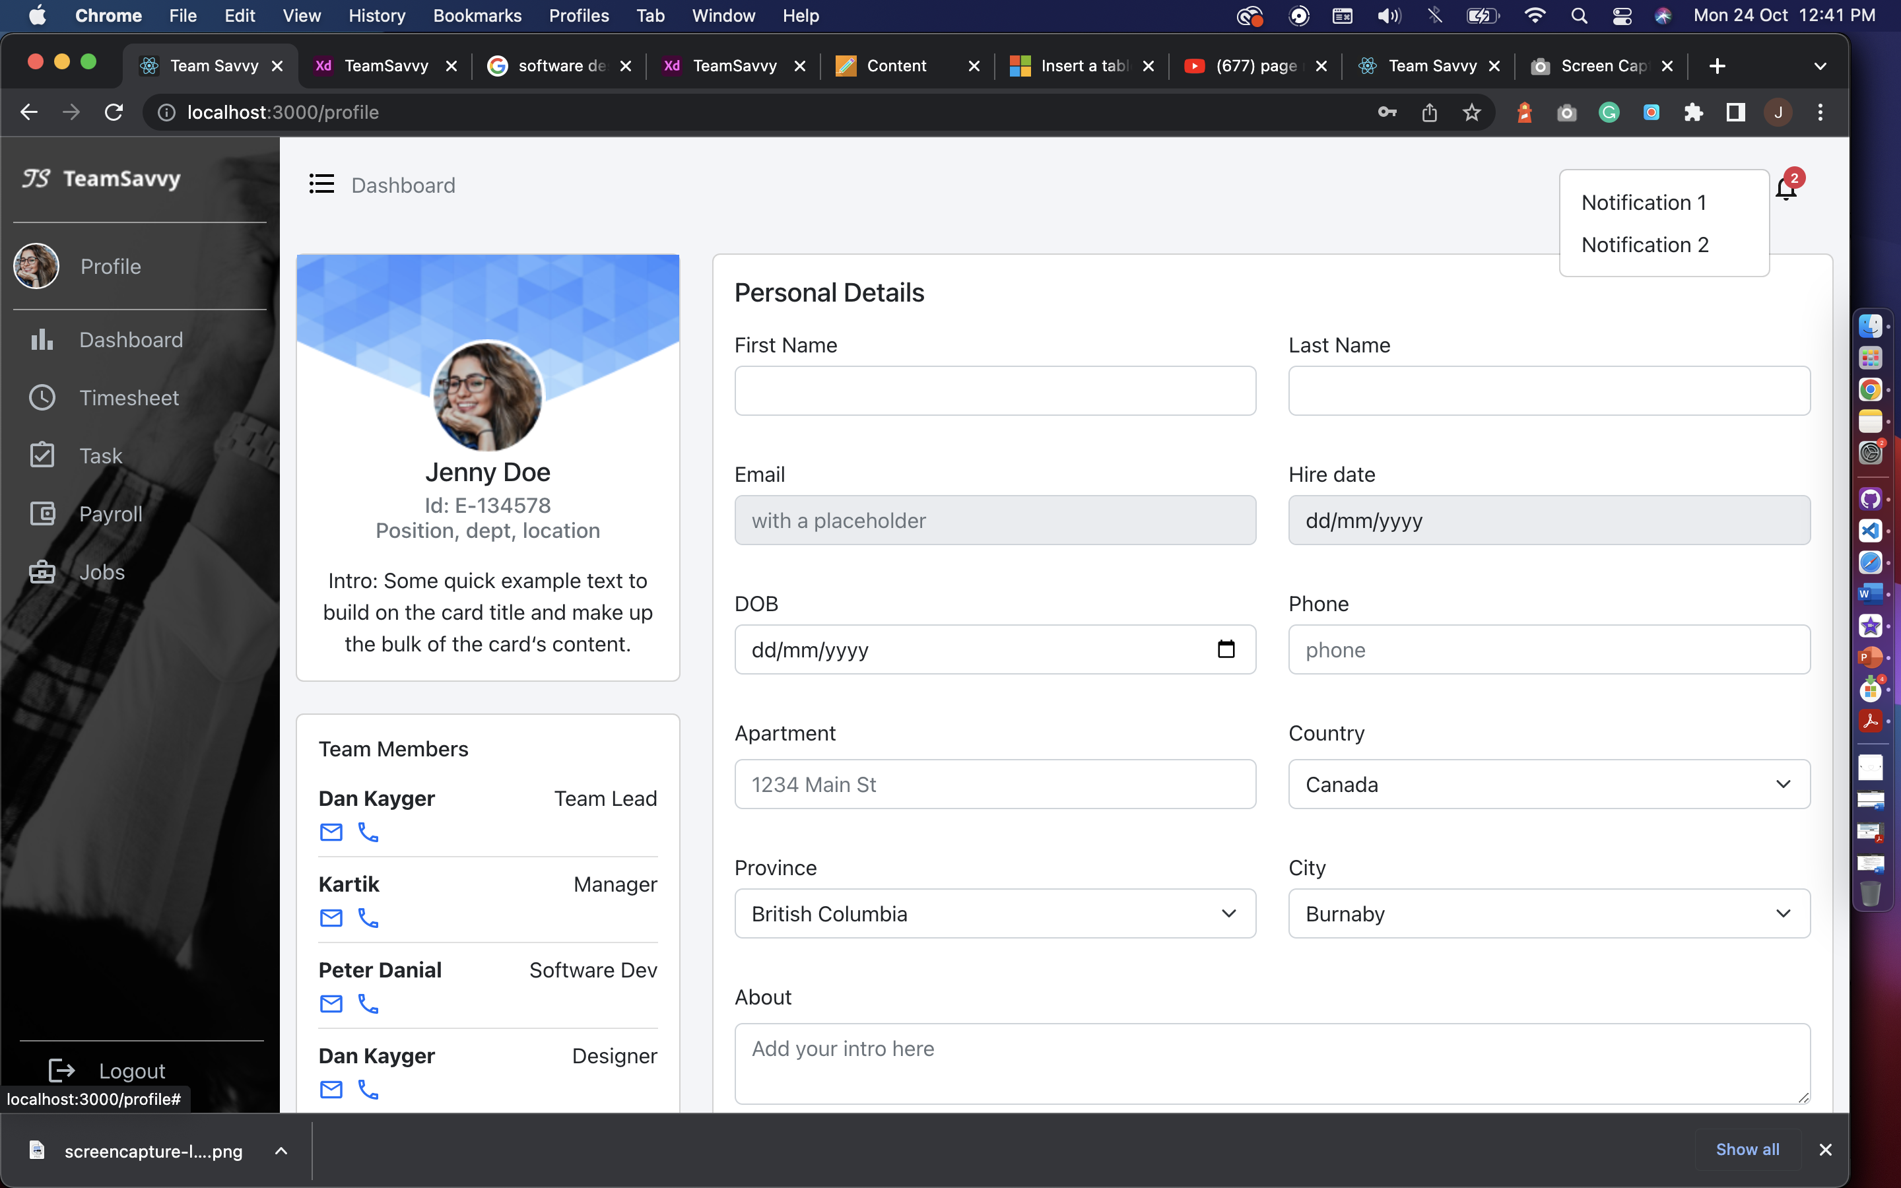

**User Profile:**

The user profile page has employee information, which is consist of Personal details, Team members with their contact details, Skill set and add new skill option, bank details, and resign option. From here HR or manager can get the overview of an employee and what skills they acquire.

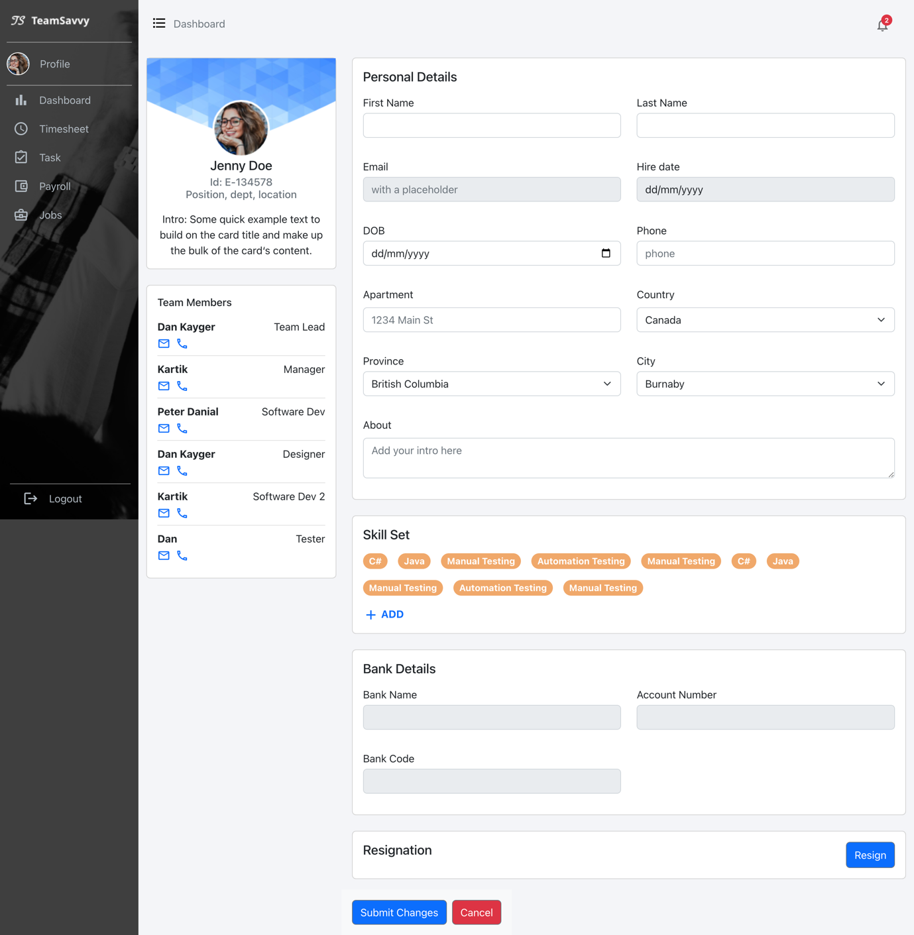

**Timesheet:**The Calendar is generated with react-big-calendar which has custom tags for leaves and popups for deleting existing leaves and add new leave. Also have clock-in and clock-out indicator. The page also has Worked total hours per week for an employee.

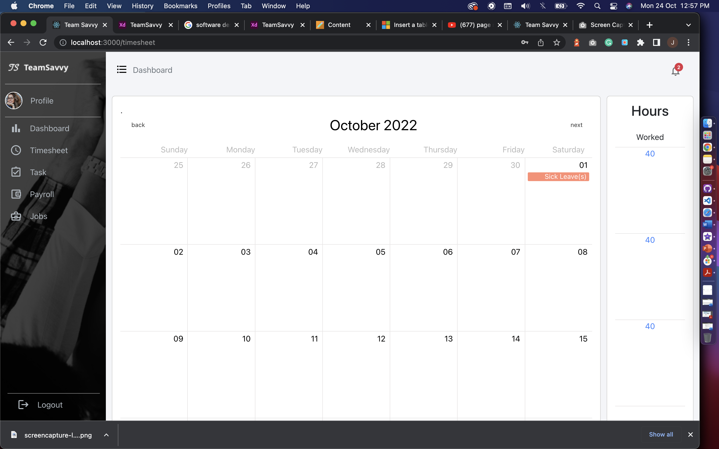

**Task:**The task page has feature to show assigned, in progress and completed tasks for an employee. We are assuming the employee only working in one project at a time. On click of modify task user will get pop-up to add hours and change status of the task. On update status, the employee can only change status to completed task.

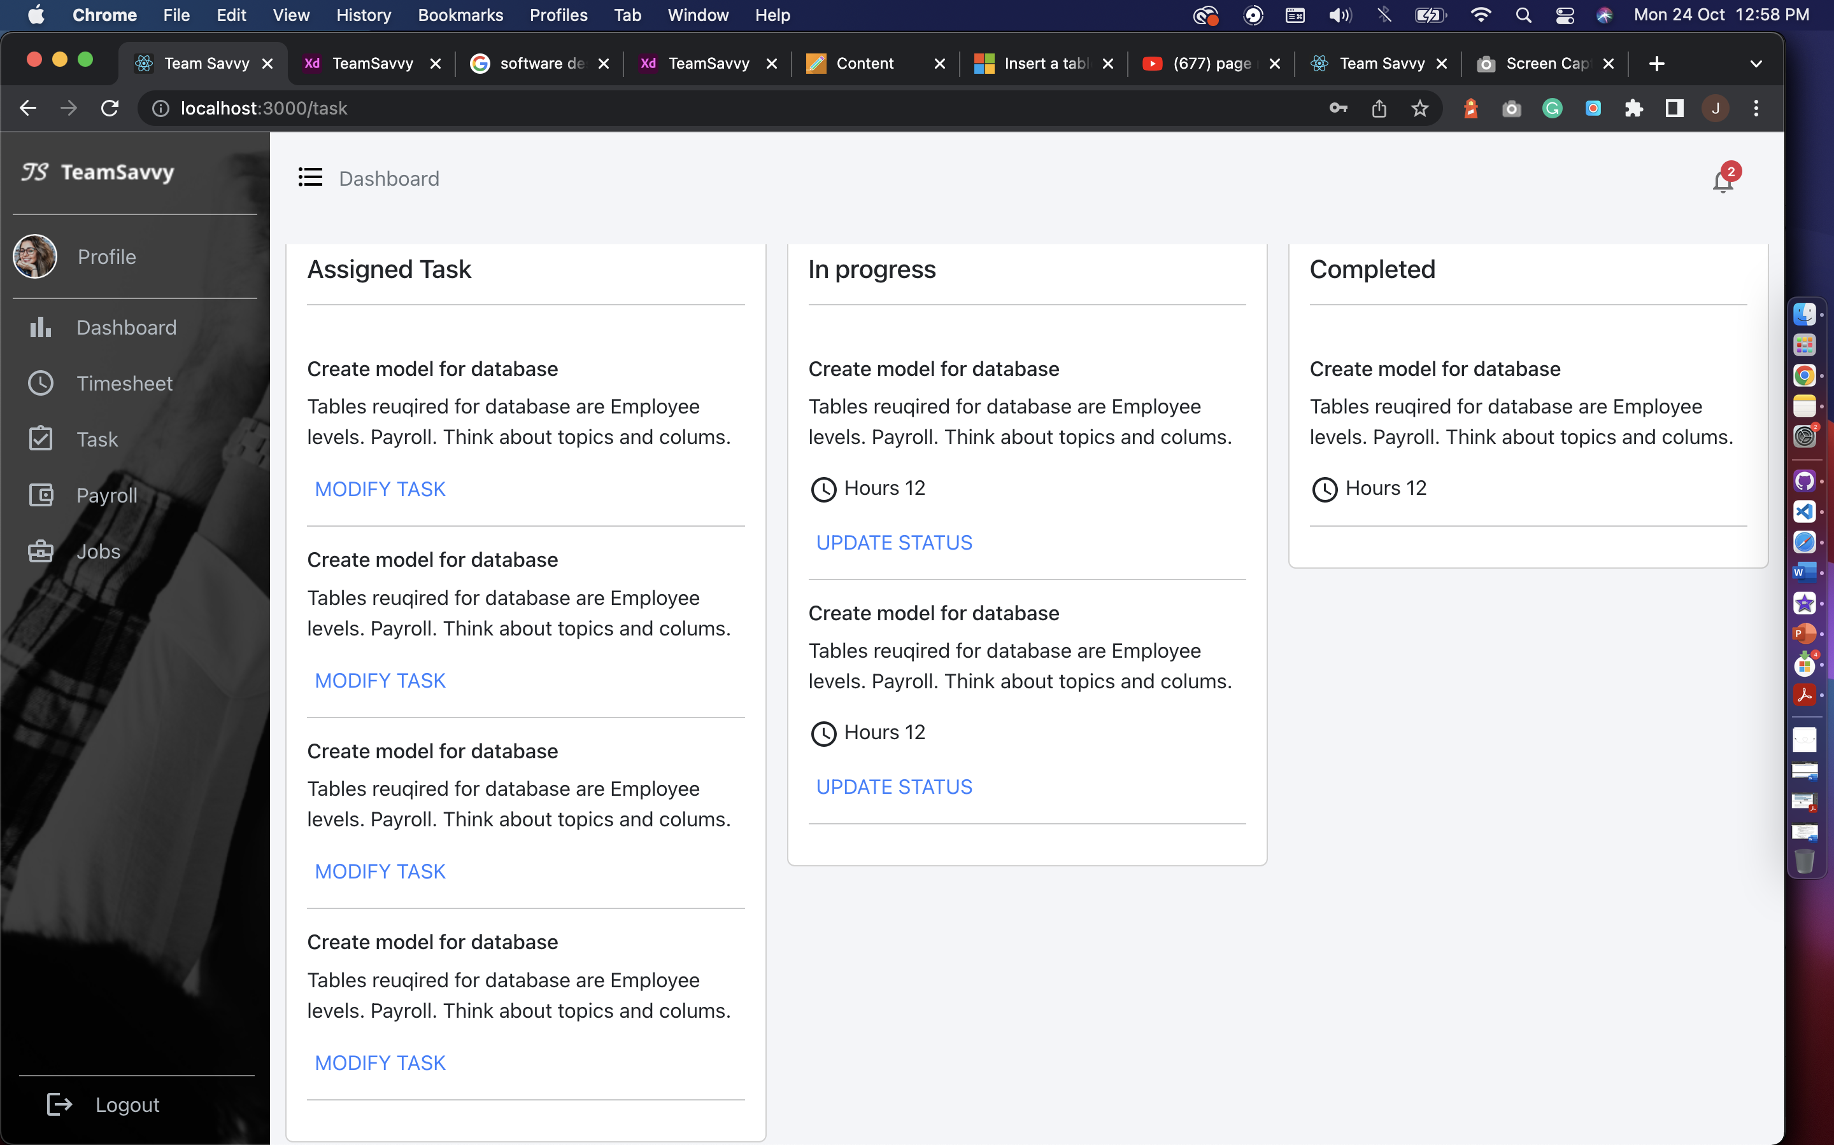

**Payroll:**The payroll has payslips screens where employee can check the list of paystubs and also can view the paystubs individually by clicking on view file.

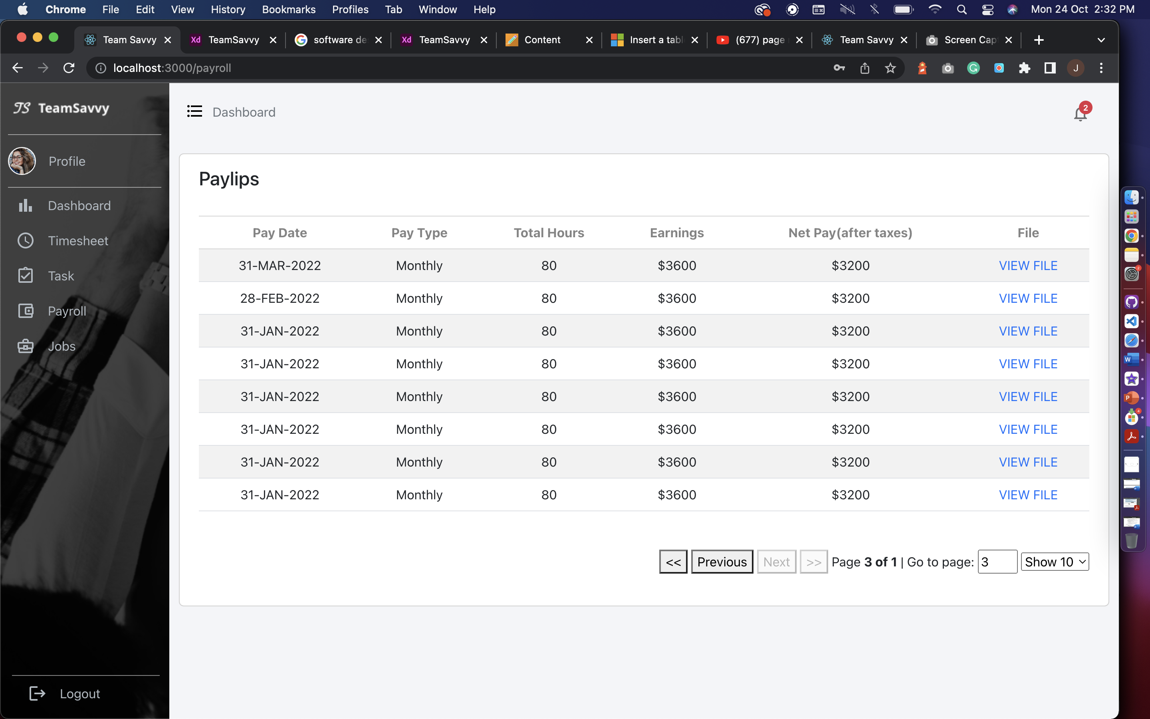



**Jobs:**The jobs page for employee have internal jobs created by HR and employee will not see the create job option. Employee can directly apply using Apply now button. HR will get the notification on their portal from where they can check the profile of an employee who applied.

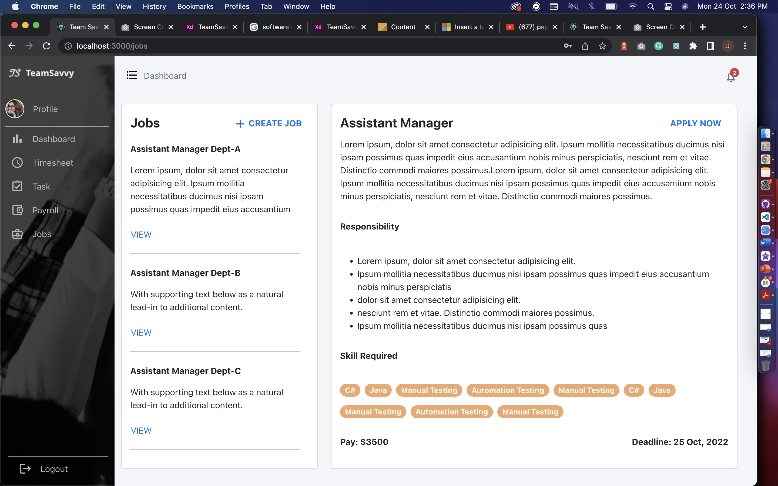

## Database

We’ve created all the Tables that are required for the functioning of the Application. These tables interlinked with each other has all the attributes that gives us the glimpse of how the Application will work.

**Structure of the Database:**

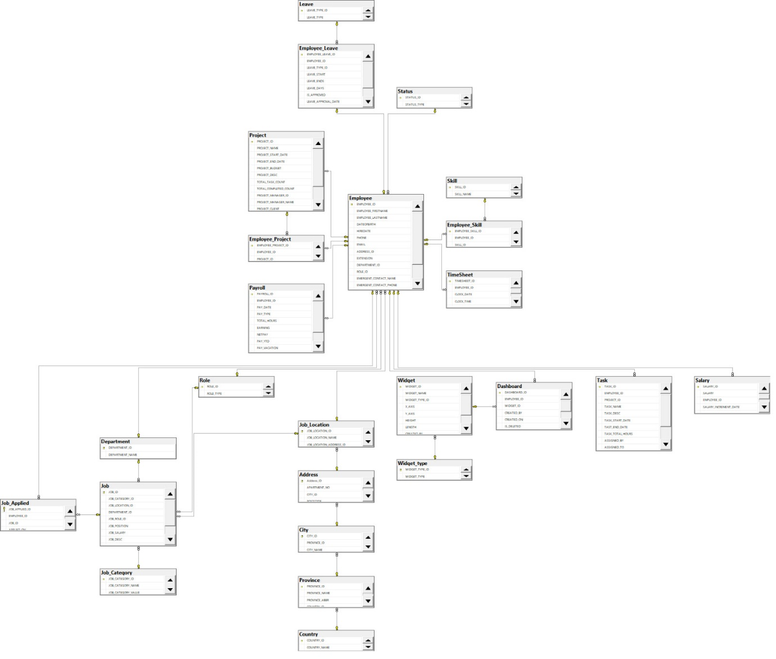

**Tables in our database:**

* **Employee**: PK-EmpID, FK – AddressID, DepartmentID, ProjectID, RoleID, StatuesID, First Name, Last Name, DOB, HireDate, Phone, Extension, Email, Bank Account No.
* **Project**: PK- PojectID, FK – Project Manager ID, Project Name, Project Start Date, Project End date, Project Budget, Project Description, Total Task Count, Total Inprogress Count, Total Completed Count, Project Manager, Project Client, Project Load, Project Total Emplyee
* **Leave**: PK – Leave Type ID, FK – Employee ID, Leave Start Date, Leave End Date, Leave Days, Leave Approval Date, Leave Approved By, Leave Status
* **Employee_Leave**: PK – Employee Leave ID, FK – Employee Type ID
* **Employee_Project:** PK – Employee Project ID, FK – Employee ID, Project ID
* **Payroll**: PK – Payroll ID, FK – Employee ID, Pay ID, Pay Date, Pay Type, Total Hours, Earning, Net Pay, Pay_Vacation, Pay_Sick
* **Status**: PK – Status ID, Status_Type
* **Skill**: PK – Skill ID, Skill Name
* **Employee_Skill**: PK – Employee Skill ID,FK – EmployeeID, SkillID
* **Time_Sheet:** PK – TimesheetID, FK – EmployeeID
* **Role**:PK – RoleID, RoleName
* **Department**: PK – DepartmentID, DepartmentName
* **Job:** PK – JobID, FK – JobCategoryID , JobLocationID, DepartmentID, JobRoleID, JobSalary, JobDesc
* **Job Applied**: PK- Job Applied ID, FK – EmployeeID, JobID
* **Job Category:** PK – JobCategoryID, JobCategoryName, JobCategoryValue
* **Job Location**: PK – JobLocationID, FK – CityID, Location, PostalCode
* **Address:** PK – AddressID, FK - CityID, Apartment, Postal Code
* **City**: PK – CityID, CityName, FK – Province ID
* **Province:** PK – Province ID, FK – Country ID, ProvinceName, ProvinceAbbreviations
* **Country**: PK – CountryID, Country Name
* **Dashboard**: PK – DashboardID,FK – EmployeeID, WidgetID
* **Widget**: PK – WidgetID, FK – WidgetTypeID, WidgetName)
* **Widget_Type:** PK – WidgetTypeID, WidgetType
* **Task:** PK – TaskID, FK – EmployeeID, FK-ProjectID, TaskName, TaskDescription, TaskStartDate, TaskEndDate, TaskTotalHours, AssignedBy, AssignedTo, AssignedDate, TaskStatus
* **Salary**: PK – (SalaryID,SalaryIncdate), FK – EmployeeID, SalaryType, Salary

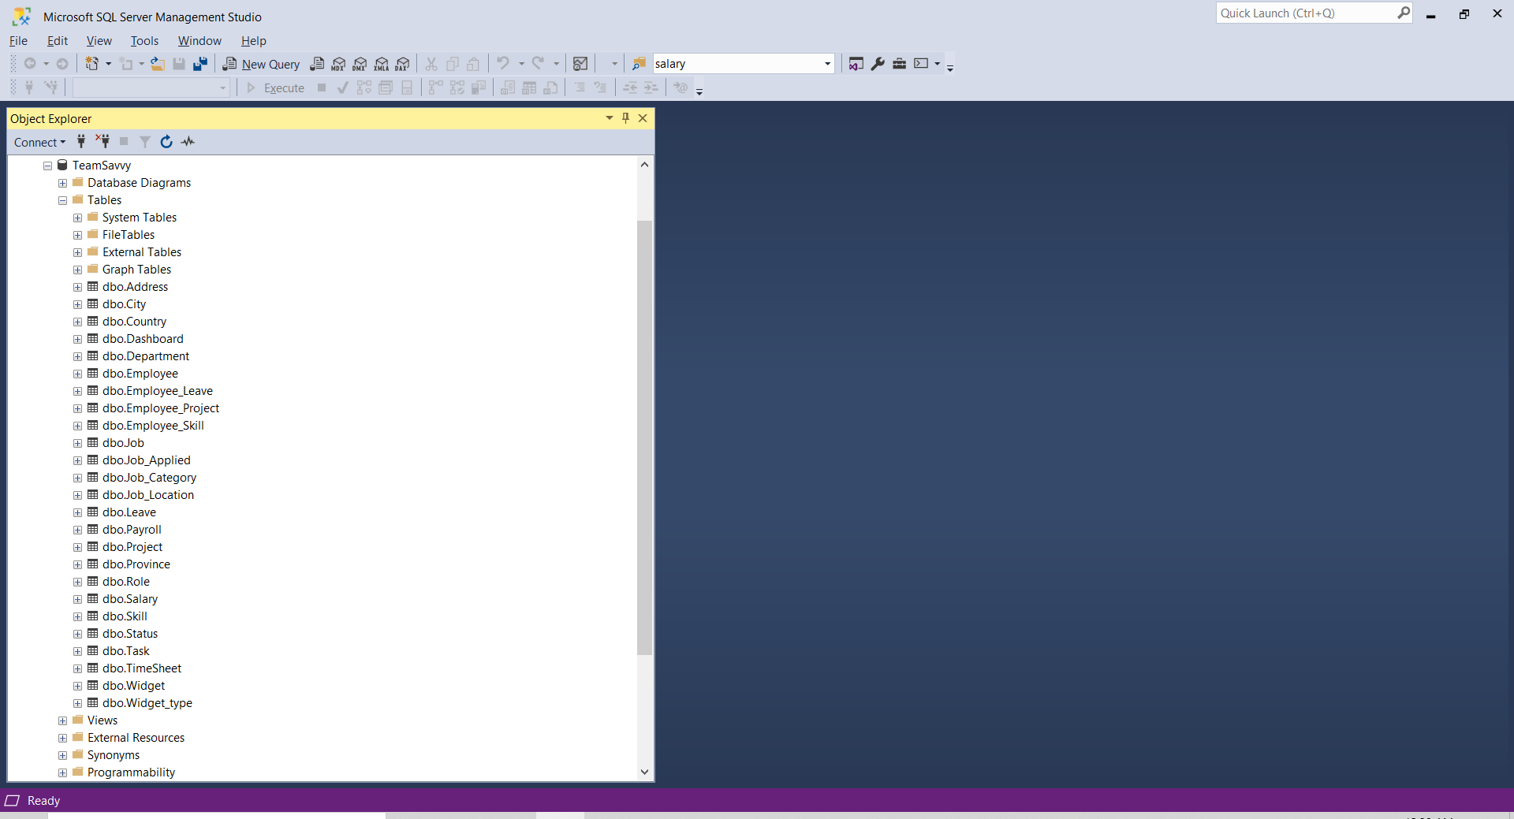

Above screenshot is about TeamSavvy database with all the tables required for application as of now and attaching the SQL script to generate the above database with tables and populate data.

# Features/module with objectives

* Our objective for the platform is to provide access of payroll, tasks, timesheet also internal company jobs to an employee at one place. We have developed side menu for easy navigation and pages to give easy access to this information to an employee.
* Our objective is for Manager or HR to have descriptive analysis using the data in our database. In our platform, manager can create custom graphs and some pre-defined widgets to give overview of the products, team members and tasks they are working on.
* Idea is to create timesheet and task together where employee can check for task pending as they are planning to take leave, rather than moving from platform to platform with our application with just one tab change like click on a timesheet he can apply for leave according to the task planning.
* To apply for an internal job employee must go to company website to apply and then upload their latest resume with skills and details. While with our platform employee can apply directly from jobs sections where HR will receive the profile of an employee in notification which will have listed the skills and other details employee have.
* For HR if they need candidates from a company working on specific programming language. They can use our graph feature to filter number of employees working on particular language.

# Set up the environment

**For setting up APIs:**

* Download Visual Studio
* Install Entity framework nuGet package
* Install Automapper nuGet package
* Install Swashbuckle.AspNetCore.Swagger

**For running application:**

* Install latest node Js
* Install latest packages for project using ‘npm install’
* Then ‘npm start’ to run application on local machine

# Software Design Architecture

For our application we are using use case diagram to show the flow and working of an application:

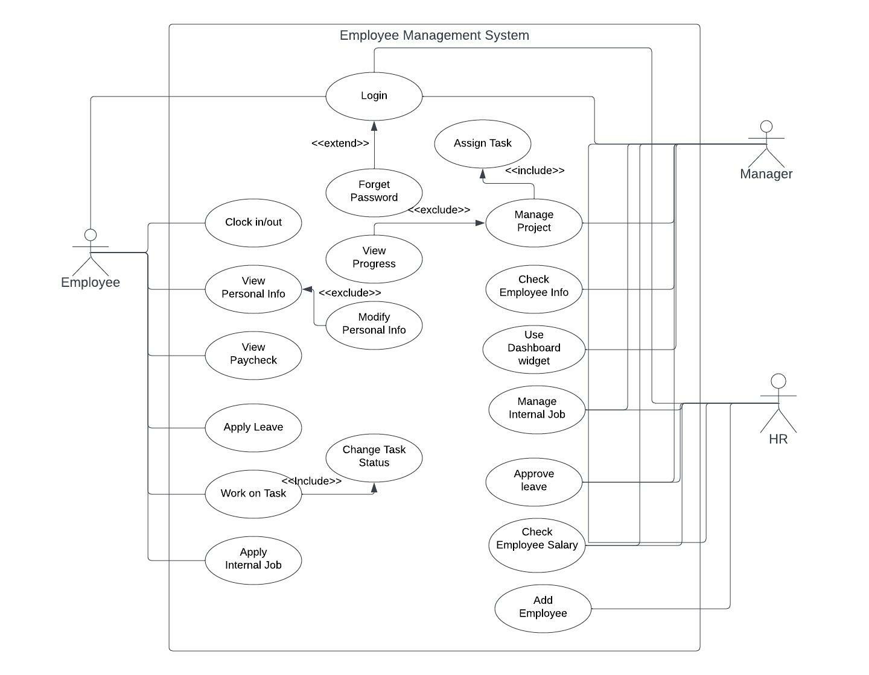

**Design Pattern applied w/ clear explanation on why it was chosen and how it was implemented**

We have created the Web APIs in .Net Core. We follow the MVC architectural design pattern and Repository Design pattern. We choose MVC (Model-View Controller) design pattern as this gives us Soc (Separation of Concern) and make our code clear to understand and reusable, easier to modify and update.

In our project we created the BAL (Business Layer), DAL (Data Access Layer) and a separate Presentation layer this help in avoiding conflict in code and give power to do independent development simultaneously. We have followed five SOLID Principle while developing our application. We have created Interface which give us power to achieve modularity and extend our code without modification. We have used Dependency Injection to register our services where we have implemented Business Logic.

We have also used Repository Design Pattern to access data layer. We have created an abstract layer between data access and business logic of our application. This gives us a loosely coupled approach to access our database and make our code modular and reusable. It also increases abstraction level of our application, in our application we implemented IRepository.cs Interface, GenericRepository.cs and GenericUnitOfWork.cs class to achieve the Repository design pattern.

IRepository.c Interface

// <summary>

/// Repository contract.

/// </summary>

/// <typeparam name="TEntity"></typeparam>

public interface IRepository<TEntity> where TEntity : class

{

#region Public Methods

/// <summary>

/// Get db set.

/// </summary>

/// <returns></returns>

IQueryable<TEntity> GetQuery();

/// <summary>

/// Get all records in memory.

/// </summary>

/// <returns></returns>

IEnumerable<TEntity> Get();

/// <summary>

/// Get record in memory with no tracking.

/// </summary>

/// <returns></returns>

IEnumerable<TEntity> GetWithNoTracking();

/// <summary>

/// Get dbSet with no tracking.

/// </summary>

/// <returns></returns>

IQueryable<TEntity> GetQueryWithNoTracking();

/// <summary>

/// Get filtered record.

/// </summary>

/// <param name="filter"></param>

/// <param name="orderBy"></param>

/// <param name="includeProperties"></param>

/// <returns></returns>

Task<IEnumerable<TEntity>> Get(Expression<Func<TEntity, bool>> filter = null, Func<IQueryable<TEntity>, IOrderedQueryable<TEntity>> orderBy = null, string includeProperties = "");

/// <summary>

/// Get record using id.

/// </summary>

/// <param name="id"></param>

/// <returns></returns>

TEntity GetById(object id);

/// <summary>

/// Get async record using id.

/// </summary>

/// <param name="id"></param>

/// <returns></returns>

Task<TEntity> GetByIdAsync(object id);

/// <summary>

/// Insert record in DB.

/// </summary>

/// <param name="entity"></param>

void Insert(TEntity entity);

/// <summary>

/// Insert list of records in DB.

/// </summary>

/// <param name="entities"></param>

void Insert(IEnumerable<TEntity> entities);

/// <summary>

/// Update entity.

/// </summary>

/// <param name="entityToUpdate"></param>

void Update(TEntity entityToUpdate);

/// <summary>

/// uppdatye entities

/// </summary>

/// <param name="entitiesToUpdate"></param>

void Update(IEnumerable<TEntity> entitiesToUpdate);

/// <summary>

/// Delete object on the basis of id.

/// </summary>

/// <param name="id"></param>

void Delete(object id);

/// <summary>

/// Delete object on the basis of ids.

/// </summary>

/// <param name="ids"></param>

void Delete(IEnumerable<TEntity> ids);

/// <summary>

/// Delete entity.

/// </summary>

/// <param name="entityToDelete"></param>

void DeleteLogical(TEntity entityToDelete);

/// <summary>

/// Delete entities.

/// </summary>

/// <param name="entityToDelete"></param>

void Delete(TEntity entityToDelete);

#endregion

}

GenericRepository.cs

/// <summary>

/// Generic database repository

/// </summary>

/// <typeparam name="TEntity">Entity of database</typeparam>

public class GenericRepository<TEntity> : IRepository<TEntity> where TEntity : class

{

#region Private Member Variables

/// <summary>

/// Db context.

/// </summary>

private readonly DbContext _context;

/// <summary>

/// Dbset.

/// </summary>

private DbSet<TEntity> _dbSet;

#endregion

#region Constructors

/// <summary>

/// Initialises a generic repository with a dbcontext.

/// Instead of creating repository for getting every data,

/// generic repository is being used.

/// </summary>

/// <param name="context"></param>

public GenericRepository(DbContext context)

{

_context = context;

_dbSet = context.Set<TEntity>();

}

#endregion

#region Public Methods

/// <summary>

/// Get records from database using filters.

/// </summary>

/// <param name="filter"></param>

/// <param name="orderBy"></param>

/// <param name="includeProperties"></param>

/// <returns>Return filtered records.</returns>

public virtual async Task<IEnumerable<TEntity>> Get(Expression<Func<TEntity, bool>> filter = null, Func<IQueryable<TEntity>, IOrderedQueryable<TEntity>> orderBy = null,

string includeProperties = "")

{

IQueryable<TEntity> query = _dbSet;

if (filter != null)

{

query = query.Where(filter);

}

foreach (var includeProperty in includeProperties.Split

(new char[] { ',' }, StringSplitOptions.RemoveEmptyEntries))

{

query = query.Include(includeProperty);

}

if (orderBy != null)

{

return await orderBy(query).ToListAsync<TEntity>();

}

return await query.ToListAsync<TEntity>();

}

/// <summary>

/// Get list of records from database.

/// </summary>

/// <returns>Return list of records.</returns>

public virtual IEnumerable<TEntity> Get()

{

IQueryable<TEntity> query = _dbSet;

return query.ToList();

}

/// <summary>

/// Get dbset.

/// </summary>

/// <returns>Return dbset.</returns>

public virtual IQueryable<TEntity> GetQuery()

{

return _dbSet;

}

/// <summary>

/// Get list of records with no tracking.

/// </summary>

/// <returns>Return list with no tracking.</returns>

public virtual IEnumerable<TEntity> GetWithNoTracking()

{

IQueryable<TEntity> query = _dbSet;

return query.AsNoTracking<TEntity>().ToList();

}

/// <summary>

/// Get dbset with no tracking.

/// </summary>

/// <returns>Return dbset with no tracking.</returns>

public virtual IQueryable<TEntity> GetQueryWithNoTracking()

{

return _dbSet.AsNoTracking<TEntity>();

}

/// <summary>

/// Find record by id in DB.

/// </summary>

/// <param name="id"></param>

/// <returns>Return record by id.</returns>

public virtual TEntity GetById(object id)

{

return _dbSet.Find(id);

}

/// <summary>

/// Find record by id in DB asyncroniously.

/// </summary>

/// <param name="id"></param>

/// <returns>Return async record by id.</returns>

public virtual async Task<TEntity> GetByIdAsync(object id)

{

return await _dbSet.FindAsync(id);

}

/// <summary>

/// Generic method to insert record in DB.

/// </summary>

/// <param name="entity"></param>

public virtual void Insert(TEntity entity)

{

_dbSet.Add(entity);

}

/// <summary>

/// Generic method to insert records in DB.

/// </summary>

/// <param name="entities"></param>

public virtual void Insert(IEnumerable<TEntity> entities)

{

_dbSet.AddRange(entities);

}

/// <summary>

/// Update record.

/// </summary>

/// <param name="entityToUpdate"></param>

public virtual void Update(TEntity entityToUpdate)

{

_dbSet.Attach(entityToUpdate);

_context.Entry(entityToUpdate).State = EntityState.Modified;

}

/// <summary>

/// update list of records.

/// </summary>

/// <param name="entitiesToUpdate"></param>

public virtual void Update(IEnumerable<TEntity> entitiesToUpdate)

{

foreach (TEntity entity in entitiesToUpdate)

{

_dbSet.Attach(entity);

_context.Entry(entity).State = EntityState.Modified;

}

}

/// <summary>

/// Delete record.

/// </summary>

/// <param name="id"></param>

public virtual void Delete(object id)

{

TEntity entityToDelete = _dbSet.Find(id);

Delete(entityToDelete);

}

/// <summary>

/// Delete list of record.

/// </summary>

/// <param name="entitiesToDelete"></param>

public virtual void Delete(IEnumerable<TEntity> entitiesToDelete)

{

foreach (TEntity entity in entitiesToDelete)

{

Delete(entity);

}

}

/// <summary>

/// Delete entity

/// </summary>

/// <param name="entityToDelete"></param>

public virtual void DeleteLogical(TEntity entityToDelete)

{

PropertyInfo prop = entityToDelete.GetType().GetProperty("Deleted", BindingFlags.Public | BindingFlags.Instance);

if (null != prop && prop.CanWrite)

{

prop.SetValue(entityToDelete, true, null);

}

Update(entityToDelete);

}

public virtual void Delete(TEntity entityToDelete)

{

if (_context.Entry(entityToDelete).State == EntityState.Detached)

{

_dbSet.Attach(entityToDelete);

}

_dbSet.Remove(entityToDelete);

}

#endregion

}

GenericUnitOfWork.cs

/// <summary>

/// Generic class for db queries.

/// </summary>

/// <typeparam name="TContext"></typeparam>

public class GenericUnitOfWork<TContext> : IDisposable where TContext : DbContext

{

#region Private Member Variables

/// <summary>

/// Generic unit of work contains a dictionary of repositories.

/// </summary>

private Dictionary<Type, object> _repositories = new Dictionary<Type, object>();

#endregion

#region Constructors

/// <summary>

/// A constructor with a generic dbcontext. This avoids coupling with a particular dbcontext.

/// </summary>

/// <param name="context"></param>

public GenericUnitOfWork(TContext context)

{

Context = context;

}

#endregion

#region Public Properties

/// <summary>

/// context property

/// </summary>

public TContext Context { get; } = null;

#endregion

#region Public Methods

/// <summary>

/// Create context connection of particular table in entity.

/// </summary>

/// <typeparam name="TEntity"></typeparam>

/// <returns>Return context object.</returns>

public GenericRepository<TEntity> Repository<TEntity>() where TEntity : class

{

if (_repositories.Keys.Contains(typeof(TEntity)))

{

return _repositories[typeof(TEntity)] as GenericRepository<TEntity>;

}

GenericRepository<TEntity> repo = new GenericRepository<TEntity>(Context);

_repositories.Add(typeof(TEntity), repo);

return repo;

}

/// <summary>

/// Save changed data in DB.

/// </summary>

/// <returns>Return number of record saved.</returns>

public int SaveChanges()

{

return Context.SaveChanges();

}

/// <summary>

/// Save changed data in DB asyncronously.

/// </summary>

/// <returns>Return number of record saved.</returns>

public Task<int> SaveChangesAsync()

{

return Context.SaveChangesAsync();

}

/// <summary>

/// Disposed bool variable initialise.

/// </summary>

private bool disposed = false;

/// <summary>

/// Method to dispose DB connection.

/// </summary>

/// <param name="disposing"></param>

protected virtual void Dispose(bool disposing)

{

if (!disposed)

{

if (disposing)

{

Context.Dispose();

}

}

disposed = true;

}

/// <summary>

/// Method for garbage collection of unused objects.

/// </summary>

public void Dispose()

{

Dispose(true);

GC.SuppressFinalize(this);

}

#endregion

}